**Calibration of Orifice Meter**

**Object of Experiment:**

To find experimentally the coefficient of velocity, the coefficient of discharge and the coefficient of contraction for a small orifice for the flow under constant head tank.

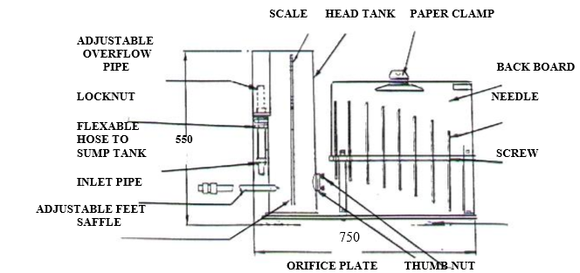

**Rules**

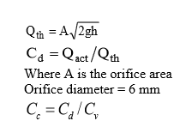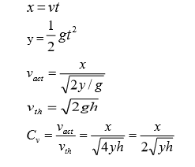

**Results and Calculations:**

|  |  |  |  |  |
| --- | --- | --- | --- | --- |
| Reading No. | Head (h) mm | Height (y) cm | Distance (x) cm | Velocity Coefficient Cv |
| 1 | 400 | 2.5 | 24.5 | 1.225 |
| 2 | 380 | 2.8 | 24.5 | 1.187 |
| 3 | 360 | 3 | 24.5 | 1.178 |
| 4 | 340 | 3.2 | 24.5 | 1.174 |

|  |  |  |  |  |  |
| --- | --- | --- | --- | --- | --- |
| Volume of water V (litre) | Time (T)  Sec. | Flow Rate (Qact)  Lit/Sec. | Flow Rate  (Qth)  Lit/Sec. | Discharge Coeff.  Cd | Contraction Coeff.  Cc |
| 1 | 24.62 | 0.0406 | 0.0792 | 0.51 | 0.416 |
| 1 | 21.89 | 0.0456 | 0.0772 | 0.59 | 0.497 |
| 1 | 21.5 | 0.0465 | 0.0751 | 0.6191 | 0.525 |
| 1 | 22.1 | 0.0452 | 0.0730 | 0.6192 | 0.527 |